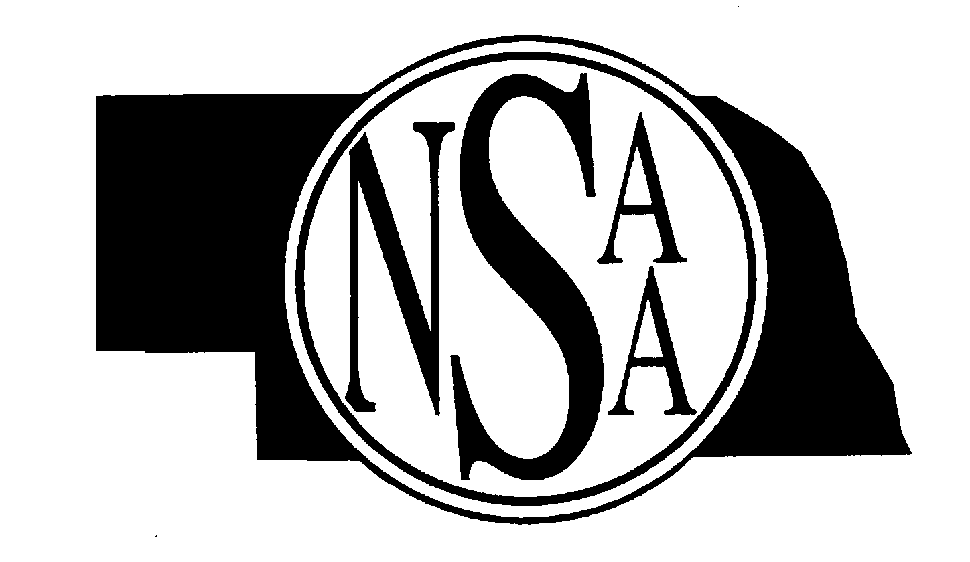
Nebraska School Activities Association
500 Charleston St. Suite #1
Lincoln, NE 68508
402-489-0386 Fax: 402-489-0934

ADJUDICATOR BALLOTS:
All District Music Contest Hosts will print their own adjudicator ballots. Ballots are found on the NSAA website, nsaahome.org, under Activities/Music/District Music Contests Adjudication Forms in PDF & Word formats. REMINDER: Current CHORAL ENSEMBLE, ORCHESTRA/STRING ENSEMBLE and BAND/WIND INSTRUMENT ENSEMBLE judges’ ballots have a “Revised 5/2011” in the lower left corner of the form. All other current ballots have “NSAA Form 2005” in that area.
PLEASE DO NOT USE FORMS THAT DO NOT HAVE THESE DATES.

MUSIC MEDALS ORDER:

The order form for additional medals is available on the internet at: nsaahome.org under Activities/Music/+General Information/ Order Form for Additional Medals.

SUPERIOR CERTIFICATES

NOTE: Superior Award Certificates for presentation to students are now accessed & printed on the NSAA website link found on each music director’s/AD’s personal page (School Login: / Personal Passcode :). AD’s can select “Music” in the Activity Select: window to access the District Music Contest Superior Award Certificates link. Certificates should be completed and printed for students using the following directions:
- School Superior Certificate (81/2 x 11)-- Large & Small Ensembles earning Superior ratings
- Individual Superior Certificate (81/2 x 51/2)—Soloists earning Superior ratings
- Individual Merit Certificates (21/4 x 4)-- Individual members of Large/Small Ensembles earning Superior Ratings
---------------------------------------------------------------------------------------------------------------------------------------------------------------------------------------------------------------------------------------------------------------------------------------------------------

Fill out this portion and return to the NSAA OFFICE—Attention Cindy Callaway
Please indicate the number needed for the following supply items:
Judges Comment Sheet (pad of 50)
# of pads
Plaques (Large Ensembles receiving three Superior Ratings)
(These may be sent to you from the award company.) # of plaques

Contest Director:

School:

Address:

City/State:

Phone:

